Clergy Collection | Share | Shrines and envelopes | Tap and Go (From Fri 18th September) | QR Code for parish Donation…if you have no cash and wish to donate
€65 | €70 | €300 | €148  (If you require a receipt please email us) | 
Standing Orders:  Total for the Month of August  €320 |  |  | Any donations received from parishioners over €250 each year are eligible for the charitable refund scheme through revenue provided the donor signs a form to allow us process the claim. This makes €250 worth €362.32 to the parish. For futher information please email the office.
Church Refurbishment Fund  (from Fri 18th September)  €25 |  |  | QR Code Donation of Choice for Church Refurbishment   | QR Code €100 Donation for Church Refurbishment  
Our Refuge in Every Age
It is wise to spend the time we have by living God’s will to the full in the present moment. Sometimes, however, we worry about the past or the future. We are concerned about situations or people for whom we cannot do anything at the moment. This is when it becomes difficult to steer the ship of our lives. It takes great effort to keep to the course that God wishes us to have in that particular moment. At such times we need strong willpower, determination, and especially trust in God, sometimes to a heroic degree.
Can I do nothing to resolve a certain complex situation or for a dear person who is sick or in danger? Then I will concentrate on doing well what God wants from me in the present: study, homemaking, prayer, taking care of the children . . . God will take care of the rest. He will comfort the suffering and show a way out of that entangled situation.
Then our trust will be rewarded. . . We will know loneliness no longer. Since we have experienced it, we will be more deeply aware of being children of a God, who is a Father and who can do everything.
Chiara Lubich, adapted from Here and Now: Meditations on Living in the Present

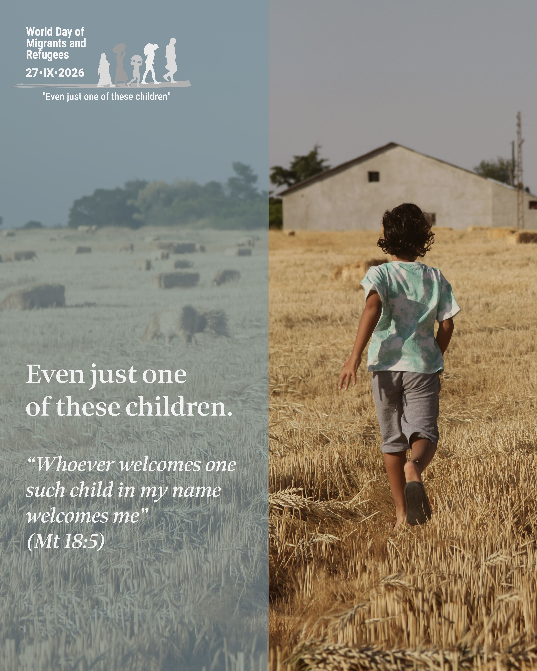
Let us entrust migrant and refugee children to the maternal protection of the Blessed Virgin Mary who, together with Saint Joseph and the child Jesus experienced the cruelty of Herod’s violence and the tragedy of exile in Egypt (cf. Mt 2:13-15). May she accompany their steps and help our communities to become living and credible signs of the Gospel. Leo PP XIV

Safeguarding Sunday
A letter from Archbishop Dermot Farrell is available at the back of the Church.
~Hospitality after Mass~ Following the 11.30am mass on Sundays - All Welcome!

