Clergy Collection | Share | Shrines and envelopes | Tap and Go (From Fri 11th September) | QR Code for parish Donation…if you have no cash and wish to donate
€85 | €70 | €450 | €130  (If you require a receipt please email us) | 
Church Refurbishment Fund  (from Fri 11th September)  €30 |  |  | QR Code Donation of Choice for Church Refurbishment   | QR Code €100 Donation for Church Refurbishment  
Crosscare Annual Appeal – Hope & Resilience

This weekend, we welcome the Crosscare Annual Appeal to our parish.
Crosscare is the social support agency of the Archdiocese of Dublin, supporting people experiencing homelessness, families facing hardship, young people, older people, migrants and refugees, and many others in our communities.

Crosscare provides accommodation and support to over 600 people experiencing homelessness, helps more than 14,000 people through its Homeless Prevention and Advocacy Service, and engages with 2,400 young people through youth services and community-based projects.

Your generosity helps bring hope and strengthen resilience for people facing difficult circumstances.
Thank you for supporting this year’s Crosscare Annual Appeal. Donations can also be made online at www.crosscare.ie
~Hospitality after Mass~ Following the 11.30am mass on Sundays - All Welcome!

Legion of Mary -  Annual Pilgrimage to Knock  The annual Legion of Mary pilgrimage to Knock will take place on Sunday 27th September, departing from Star of the Sea church at 8.00 am, Merrion Church at 8.15 am and Baggot Street convent at 8.30 am. We will be back at around 10 pm. Cost for the bus, morning coffee/tea and evening meal is 60 Euros and 25 Euros for children.  Contact Eddy at 0894908722  Christ the King Men’s Retreat  This retreat will be held on the 26th September , St. Raphaela’s Convent, Stillorgan from 9.00am to 1pm. If interested please text 087-3313676. | 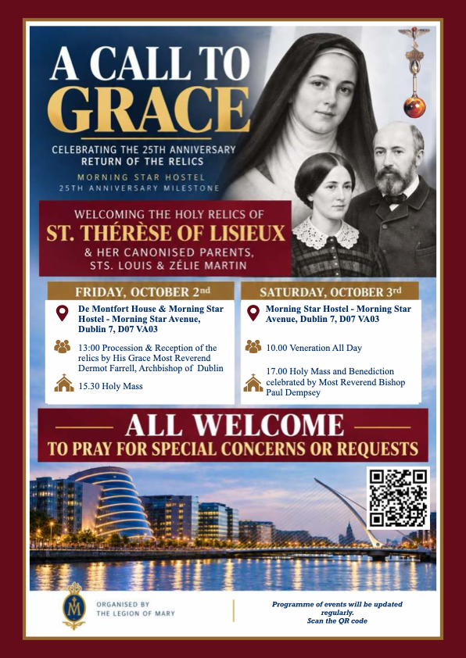
Church Refurbishment
A contractor has been approved by the Diocese and Finance Committee and appointed to lead the church refurbishment. There are still a few more steps to be carried out and dates to be decided upon before work begins but we will keep you informed during the the coming weeks.

