Clergy Collection | Share | Shrines and envelopes | Tap and Go (From Fri 31st July) | QR Code for parish Donation…if you have no cash and wish to donate
€100 | €50 | €325 | €65  (If you require a receipt please email us) | 
Church Refurbishment Fund  (from Fri 31st July)  €150 |  |  | QR Code Donation of Choice for Church Refurbishment   | QR Code €100 Donation for Church Refurbishment  

Feast of the Assumption of Mary 15th August - Mass Times
St. Andrew’s Westland Row - 10am
Church of the Immaculate Heart of Mary City Quay 6pm

CALLED AGAIN AND AGAIN
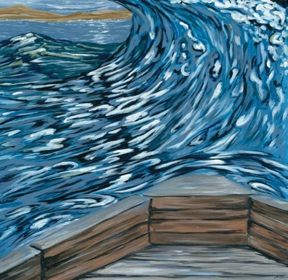
Part of Peter’s attractiveness is surely that he is so very human. He can reach for the stars one moment and fall on his face the next, or profess his undying loyalty to Jesus and then crumple before the accusing word of a serving-girl. We look here at Peter’s second call, which can serve as a reminder to all of us would-be disciples that Jesus does not simply call once and unequivocally, but that the call is reiterated in various ways throughout the lifetime of those who attempt to be attuned to the promptings of God, and who are not dispirited or destroyed by their own failures. God’s love is greater than our sinfulness and God’s covenant remains in force until the end of time. What is required of us, therefore, is an increase in faith and trust and a willingness to persevere. Peter is an example to all of us that we do not have to be perfect or infallible, but only persevering and faithful.
Step Into the Swell L G Garrity
Although Jesus has told him not to be afraid, he could not help himself and, inevitably, began to sink. But in the very moment of his awareness that he was sinking, “he cried out, ‘Lord, save me!” What Peter needed was steadfastness, not fickle faith; little faith is just not good enough for a true disciple. Fr. Tony Gittins, adapted from The Way of Discipleship
SAVE THE DATE!
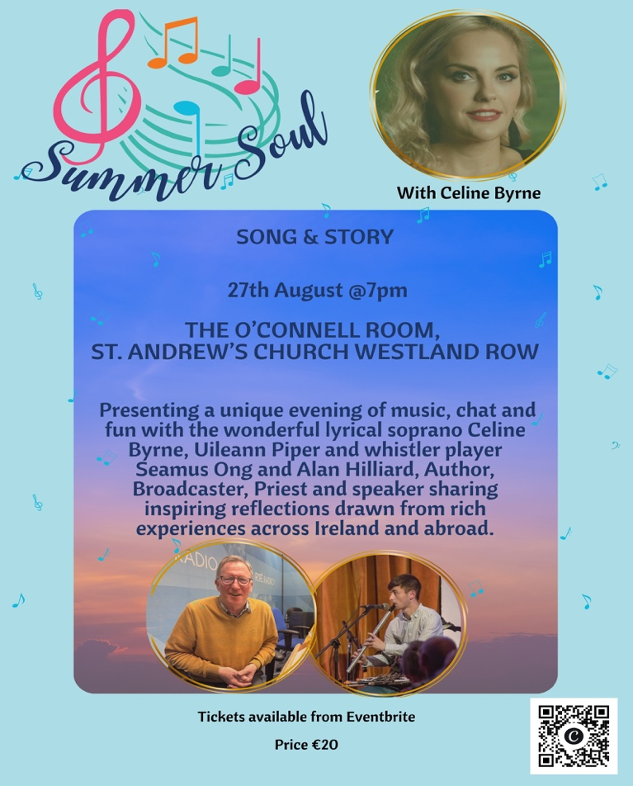
~Hospitality after Mass~ Following the 11.30am mass on Sundays - All Welcome!

