Clergy Collection | Share | Shrines and envelopes | Tap and Go (From Fri 17th July) | QR Code for parish Donation…if you have no cash and wish to donate
€60 | €50 | €225 | €197  (If you require a receipt please email us) | 
Church Refurbishment Fund  (from Fri 17th July)  €280 |  |  | QR Code Donation of Choice for Church Refurbishment   | QR Code €100 Donation for Church Refurbishment  

WELCOME
We would like to extend a very warm welcome to Fr. Teodor Avram SJ who has been appointed to the parishes of City Quay and Westland Row. Please keep him in your prayers as he settles in and gets to know our communities.
~Hospitality after Mass~
Following the 11.30am mass on Sundays - All are welcome!

WORLD DAY FOR GRANDPARENTS AND THE ELDERLY
This Sunday, July 26th , is the Sixth World Day for Grandparents and the Elderly. Grandparents and the Elderly are the backbone of every parish. They are people deeply committed to their faith and to the mission of the Church. The theme chosen by Pope Leo XIV “I will never forget you” (Is 49:15) reminds us that God’s unwavering love is the ultimate answer to isolation and neglect so often experienced by the elderly. It brings comfort and hope, assuring us that the Lord knows each of us personally, forgets no-one and loves us unconditionally, even through the frailties of old age.

Prayer for the 6th World Day for
Grandparents and the Elderly
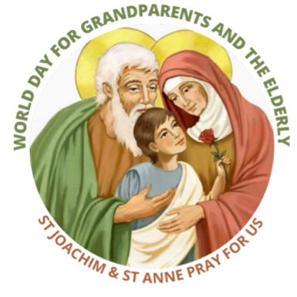
Holy Father
Who watches over every person
Watch over me too when I am elderly.
You have revealed your name to me in Christ,
And You were not discouraged by my frailties.
You hold me tenderly in your hands,
And You caress my lines.
You will never forget me!
Grant that I may not fear my weakness;
Help me learn to love it
Just as You love it.
Help me learn to listen to it
Just as You listen to it.
Help me embrace it
Just as You have chosen it –
You who, though all-powerful, clothed yourself in humility.
May growing old strip away all our pride
and all division
So that we may live these years
united in You.
You will never forget us!
Amen.

