Clergy Collection | Share | Shrines and envelopes | Tap and Go (From Fri 10th July) | QR Code for parish Donation…if you have no cash and wish to donate
€50 | €65 | €330 | €146  (If you require a receipt please email us) | 
Church Refurbishment Fund  (from Fri 10th July)  €120 |  |  | QR Code Donation of Choice for Church Refurbishment   | QR Code €100 Donation for Church Refurbishment  

Elemental Vitality
The growth of the seeds is independent of the farmer’s thought, hopes, actions, except obeying the fundamental proposition that’s involved in the seed/dirt relationship. Once that has been obeyed, then there isn’t any more that can be done, that the mystery that surrounds the swelling of the kernel and the bursting open and the releasing of the elemental vitality that is transformed in terms of shoots and leaves and the rest of it. All of that is an act of God.
What does that mean? About the kingdom of God, the only thing that I am responsible for doing, Jesus seems to suggest, is to be sure that to the limit of my power I do the elemental cooperation: I see that I do not block the process. That I lay bare my mind and will and heart to what seems to me to be the truth of God, and that I follow the light that I have.
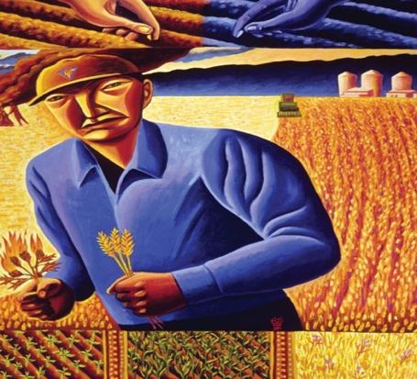
The kingdom of God is like a seed that is planted by a farmer, and he plants it and knows that he is responsible for doing all that his power permits, bringing to bear upon the selection of his seed as much wisdom and intelligence and farmer sense as he is able to garner. And after he has exhausted all of his resources in that particular, to cooperate with the relentless logic of the process of growth.
The Wheat and the Weeds J B.Janknegt
Howard Thurman, Sermons on the Parables
Howard Thurman was an American author, philosopher, theologian, educator, and civil rights leader

Giving Thanks For Summer
Father, Creator of all, thank You for summer!
Thank you for the warmth of the sun
and the increased daylight.
Thank You for the beauty I see all around me
and for the opportunity to be outside and enjoy Your creation.
Thank You for the increased time I have to be with my friends and family,
and for the more casual pace of the summer season.
Draw me closer to You this summer.
Teach me how I can pray
no matter where I am or what I am doing.
Warm my soul with the awareness of Your presence
and light my path with Your Word and Counsel.

~Hospitality after Mass~
Following the 11.30am mass on Sundays - You are warmly welcomed!

