Clergy Collection | Share | Shrines and envelopes | Tap and Go From Fri 15th May | QR Code for parish Donation…if you have no cash and wish to donate
€50 | €40 | €220 | €67  (If you require a receipt please email us) | 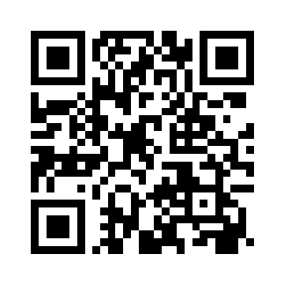
Hospitality after Mass
Following the 11.30am mass on Sundays, we would like to invite you to some refreshments at the back of church. Come meet and chat with fellow parishioners. Thanks all the volunteers involved. All are welcome!

Dublin Diocesan Pilgrimage to Lourdes 2026
The pilgrimage this year will be led by Archbishop Dermot Farrell and will take place from the 3rd to the 5th of September. See further details on the posters in the church. Assisted Pilgrim Application forms are available through the parish office.

Pentecost Sunday
Archbishop Farrell’s Pastoral Letter for Pentecost Sunday is available at the back of the church.

Beginning Experience . -Separated, Divorced, Widowed Are you coping?
Few people are able to cope alone with the pain and loneliness following the loss of a life partner. Do you find that you need more support than family and friends can provide? Beginning Experience is a peer support group dedicated to helping those who are navigating life following the loss of a life partner. Structured programmes are run by a team of trained facilitators, who are themselves widowed, separated or divorced.
The Dublin Beginning Experience Team is planning a Three Day Coping with Life Alone Programme which will take place over three Saturdays: Saturday 6thJune 20th
June and 27thJune 2026 (Advance Booking Essential) Venue: Carmelite Community Centre, Whitefriar Street, Dublin 2.
For further information contact Beginning Experience 086-0877379, or email:bedublin@gmail.com
The Gift of a Listening Heart
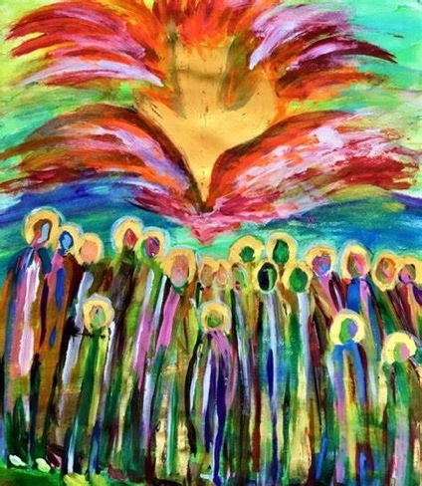
Sometimes I attend a talk with friends and afterward we start to debrief together. Occasionally this thought surfaces: Did we go to the same presentation? You heard one thing; I heard another. You are inclined to respond in one way but I heard a different challenge altogether. Language is like that: sometimes crystal clear, yet often opaque and in need of interpretation.
Imagine the disciples and their Pentecost experience as the Spirit empowered them to proclaim the Good News. They were astounded and amazed as they began to speak, each in his or her own tongue, yet heard by onlookers in their native language. A cacophony of voices, yet by some miracle their hearers were able to understand. That was the power of the Spirit in their midst.
In our day, the cacophony of voices continues, reflecting differences of country and culture, of course, but also the more intangible realities rooted in socioeconomics, politics, and ecclesiology. Sometimes silos protect us from engaging the other on a daily basis, but they cannot—nor should they—shelter us completely from the divergent voices on social media or within family discord. We need that same miracle of grace among us, a desire to listen and understand rather than cut off and dismiss.
Pentecost 2017 Ronald Raab,CSC
And what about our country and our Church? What about learning to live with—and love—such widely divergent voices, truly believing that each voice has a piece of the truth that binds us together? On this Pentecost anniversary, let us pray for the miracle of unity that only the Spirit can provide, and for the gift of a listening heart to pick up the nuances and receive the wisdom of the Spirit who is our source of unity and peace. Sr. Kathleen Hughes
Kathleen Hughes, a Religious of the Sacred Heart of Jesus (RSCJ), has written extensively on sacraments, liturgy, and spirituality.

