Clergy Collection | Share | Shrines and envelopes | Tap and Go From Fri 8th May | QR Code for parish Donation…if you have no cash and wish to donate
€55 | €45 | €275 | €321  (If you require a receipt please email us) | 

Hospitality after Mass
Following the 11.30am mass on Sundays, we would like to invite you to some refreshments at the back of church. This will be lovely occasion to meet and chat with fellow parishioners. We thank all the volunteers involved. All are welcome!

Novena to the Holy Spirit
This weekend we begin our annual Novena to the Holy Spirit for the renewal of the Church in the Archdiocese of Dublin. The Novena will conclude on Monday 25th May, the Feast of Mary, Mother of the Church. You are invited to join in the Novena Prayer each day at home or here at daily Mass over the next nine days.
Novena Prayer Cards are available at the back of the Church.

Beginning Experience . -Separated, Divorced, Widowed Are you coping?
Few people are able to cope alone with the pain and loneliness following the loss of a life partner. Do you find that you need more support than family and friends can provide? Beginning Experience is a peer support group dedicated to helping those who are navigating life following the loss of a life partner. Structured programmes are run by a team of trained facilitators, who are themselves widowed, separated or divorced.
The Dublin Beginning Experience Team is planning a Three Day Coping with Life Alone Programme which will take place over three Saturdays: Saturday 6thJune 20th
June and 27thJune 2026 (Advance Booking Essential) Venue: Carmelite Community Centre, Whitefriar Street, Dublin 2.
For further information contact Beginning Experience 086-0877379, or email:bedublin@gmail.com
Ascension
As we celebrate the Lord’s return to His Father in Heaven – His Ascension -we are being commissioned to go forth and proclaim the Gospel of life and love, of hope and peace, by the witness of our lives. On this day of hope, encouragement and commissioning, let us renew our commitment to be true disciples everywhere we go, beginning with our family and our parish.

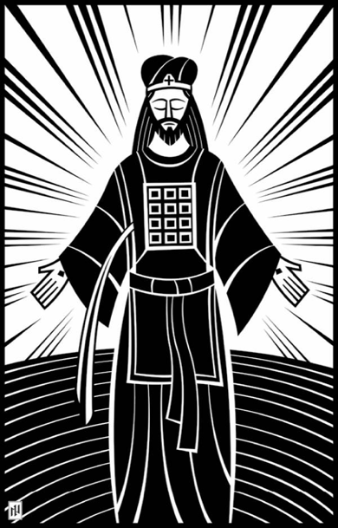
Perhaps some of the nagging doubts, which inevitably accompany the journey of Faith, could be lessened by our meditating on the Ascension and its implications. When we are too far from Faith to pray on our own, let us remember that we have an advocate with the Father, Jesus Christ, the Righteous, praying for us. When the trials of life feel too heavy to bear, we must remember that Christ will come again in glory, the same glory in which he arose from the tomb, the same glory in which he ascended, and the same glory in which he currently abides. Though our limited perception might find him absent, he is fully present, participating in every moment of our lives. By His Ascension, Christ has not deserted us but has made it possible for the Holy Spirit to enter all times and places. In this way it is possible for each of us to be transformed by the power of the Holy Spirit into agents or instruments of Christ. We are enlivened, and our actions become animated in a new way by Holy Spirit as we serve the God we love. We have become Christs in the world.
Christ the High Priest. Ian Welch

(Extract from Reflections on Ascension Sunday Fr. Antony Kadavil)
Fr. Antony Kadavil is a contributor to Vatican News

