Church Collections.
Clergy Collection | Share | Shrines and envelopes | Tap and Go From Fri 10th April | QR Code for parish Donation…if you have no cash and wish to donate
€50 | €45 | €250 | €130.50  (If you require a receipt please email us) | 
Changed Hearts
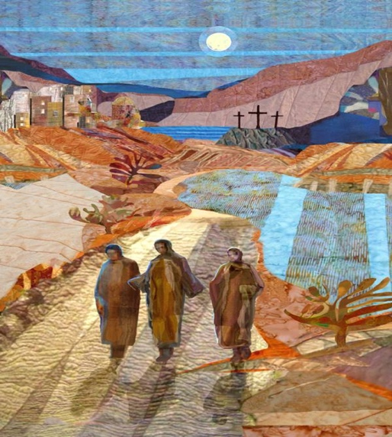
During a summer break in college, I travelled with parents and high-school students to visit Catholic families in Mexico. The journey expanded my naïve horizons about poverty, simplicity, and survival. One day, we travelled into mountain territory on narrow paths as we faced sick kids, a gas shortage, and exhaustion. The next day, another chaperon turned to me with revelation and stated, “This journey has changed you.”
Along with Jesus, the disciples were changed. Jesus’ presence, miracle-making, and mercy expanded the disciples’ imagination, courage, and integrity. After Jesus’ resurrection, the disciples shook with fear as they recognized the reality of his new life. Some were foolish, slow to believe, while others proclaimed the unimaginable story of his rising from the dead.
Road to Emmaus Michael Torevell
The Risen Christ changes how we perceive our life journey. The Risen Christ reveals to us deeper courage than any scar we carry in our hearts or any wound that we consistently hold. In Easter, we find our ease and our joy no matter how we stumble or fall, no matter our sin or heartache. Christ shows us the path to life, to deep resources of joy. In the Eucharist, the wounded and redeemed Body of Christ is present for us to taste and is shared with us as balm. Eucharist is our inheritance through baptism.
Jesus’ journey changes us. Our hearts burn with joy when we finally surrender our earthly sufferings to Christ’s love that is revealed among us who face hardship and narrow paths.
Fr. Ronald Patrick Raab
Fr. Ronald Patrick Raab, CSC, serves as religious superior at Holy Cross House, a medical and retirement facility at Notre Dame, Indiana. He is an award-winning author and visual artist. Learn more at ronaldraab.com

Update on Church Refurbishment
The architect conducted an on-site visit to our church last week to gather information and take pictures to help with the documenting and preparation for refurbishment. During that visit the carpet on the altar was rolled back to uncover the beautiful mosaic floor beneath. The items in the church are being measured and the tender documents are being prepared. Say a prayer that all will continue smoothly and that the rising costs of everything that are being felt world-wide won’t put pressure on our plans!

