Church Collections.
Clergy Collection | Share | Shrines and envelopes | Tap and Go From Fri 27th March | QR Code for parish Donation…if you have no cash and wish to donate
€35 | €25 | €265 | €189  (If you require a receipt please email us) | 

Wishing everyone a Happy and Holy Easter  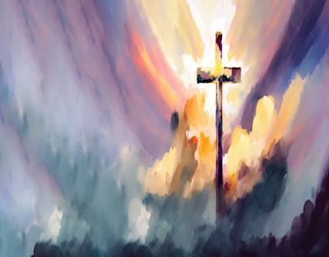  During the week there will be no 8am mass in City Quay. There will be 10am in Westland Row. The Rosary will be recited at 12 noon Monday to Friday. | 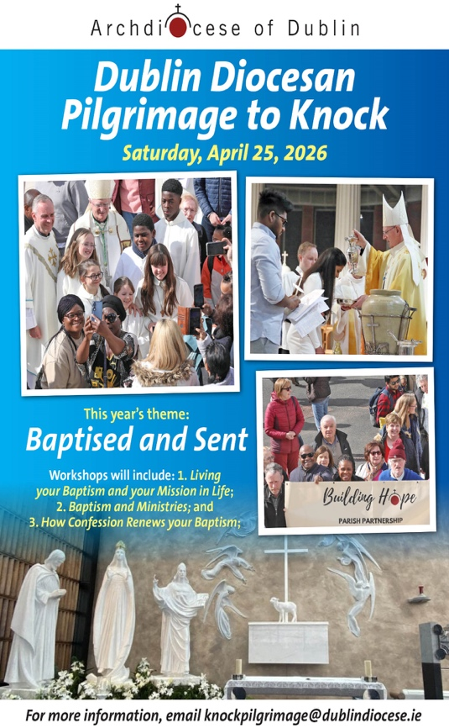
Faith Rises
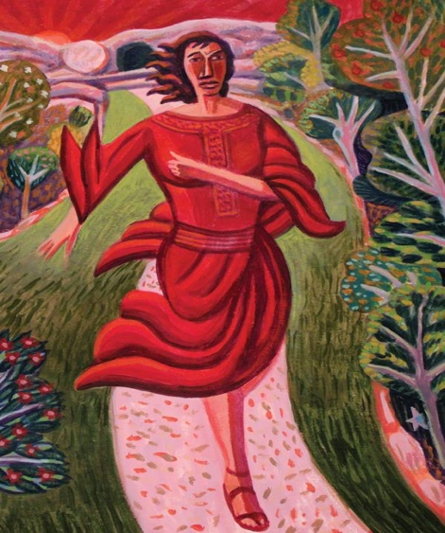
Easter morning the greeting rings out: “Christ is risen! He is risen indeed, Alleluia!” Indeed, nearly two millennia removed, we rest in the certainty of the Resurrection.
Yet, as the sun rises on this Easter Sunday, before rattling off a string of alleluias, we might do well to remember what gripped the disciples that first Easter morning: confusion. Greeted by an empty tomb, they did not know what to believe. As John’s Gospel clearly conveys, they saw and “they did not yet understand.” Had Jesus’ body been taken, or had he risen to glory like he said he would?
Each disciple meets the moment in their own way. For Mary, this means delivering the news—both of loss and, later, of joyful reunion—to her companions. For Peter, it means running out ahead, his understanding eventually catching up to his bold actions. For the Beloved Disciple, it means attending to the signs left behind and believing in the glory of the Risen One yet to be encountered.
Mary Magdalene James B. Janknegt
Each, in their own way, reveals to us that from the ashes of our own understanding, faith rises. Amid chaos and confusion, Christ lives. God meets us in this moment. Bearing the marks of pain and suffering, the effects of betrayal and the wounds of faith, Jesus greets us on this new day and offers us—all at once and yet again—new life. Alleluia!
This is the Paschal Mystery—the Easter story come alive—that with each dying and rising we might understand Christ’s love more fully, rejoicing in the One who holds us in our confusion, and helps us understand more and more each day that the Way, the Truth, and the Life of Christ will lead us home as we walk with one another. Sr. Colleen Gibson
Colleen Gibson is a Sister of Saint Joseph of Philadelphia who currently serves as coordinator of pastoral care at St. John - St. Paul Catholic Collaborative. A writer and speaker, she cohosts the podcast Beyond the Habit ( beyondthehabitpod.com).

