Church Collections.
Clergy Collection | Share | Shrines and envelopes | Tap and Go From Fri 6th March | QR Code for parish Donation…if you have no cash and wish to donate
€50 | €35 | €315 | €157  (If you require a receipt please email us) | 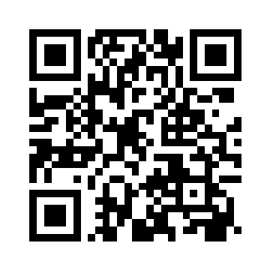

HOLY WEEK MASS TIMES  Holy Thursday  The Mass of the Lord’s Supper will be broadcast live from City Quay Church at 4.40 pm on Thursday the 2nd of April. Please note there will be no Mass of the Lord’s Supper in Westland Row, please attend in City Quay Church.  Good Friday  The Ceremony of the Lord’s Passion will be broadcast live from University Church at 3 pm on Friday the 3rd of April. Details of the events in City Quay and Westland Row to follow.  Holy Saturday  The Easter Vigil will be broadcast live from Westland Row at 11pm on Saturday evening the 4th of April. There will be no Easter Vigil in City Quay. | RTÉ MASSES HOLY WEEK  PARTICIPANTS WANTED  RTE will be broadcasting our Holy Thursday Mass of the Lord’s Supper, from City Quay Church at 4.40pm on the 2nd of April and The Easter Vigil from Westland Row at 11 pm on the 4th of April.  We are recruiting readers and participants for these broadcasts. If you are free and wish to volunteer you have to be available on the day for the ceremonies and earlier in the afternoons of each event for rehearsals.  ️️️️️️️  ST. PATRICK’S DAY MASS TIMES  Monday 16th March - 6.00pm  Tuesday 17th March - 11.30am  ️️️️️️️
Mud, Muck, and Beauty
On this day, mud is serious business. It is part of the “work” Jesus is doing—work he describes with a bit of mystery: “We must work the works of him who sent me while it is day.” Mud and spit—the very work of God.
John’s Gospel is no stranger to symbolism, nor is it shy about evoking the ancient book of Genesis. And no doubt some readers hear in this healing story echoes of the earliest work of God—creation. God, gathering dust and dirt and breath, mixing it all, and creating something living. Jesus does this work now, creating something new, restoring something ancient—humankind (adam)—from the earth (adamah).
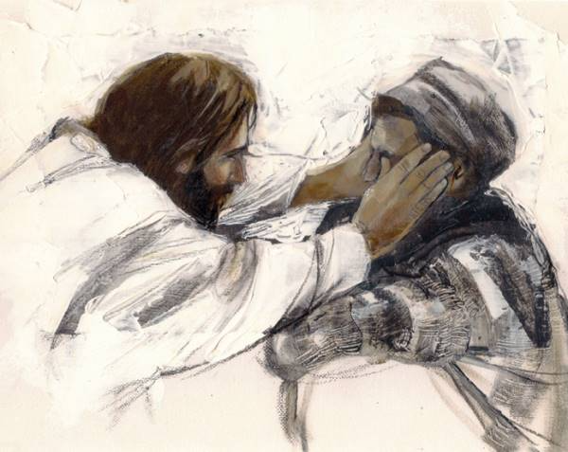
We may find it confusing, even problematic, that Jesus explains this man’s lifelong blindness by telling his disciples that the man “was born blind so that God’s works might be revealed in him.” We mustn’t interpret this to mean that people suffer for the sake of God’s glory. Rather, suffering is a reality of the human body and of human living. It is not the fault of the suffering person or his family (a point Jesus insists upon). And it is certainly not the desire of God, as the healing ministry of Jesus gives witness. But Jesus’ observation is, at its
Jesus Heals A Blind Man Alida Bothma
heart, a recognition that God does work within the medium of human suffering—in all its mud and muck. Like a masterful creator, or a child after a rainstorm, God can make or imagine or restore beautiful things from what appears to us to be a mess.
Human suffering is not God’s sandbox. It isn’t a place where God plays or experiments. But it is a place where God lives and participates, a place where, for now, the mud is still being mixed and spread, where creation is still happening.
Amy Ekeh, adapted from Stretch Out Your Hand
Amy Ekeh is the director of mission advancement for the Apostles of the Sacred Heart of Jesus. She is an author, retreat director, and adjunct professor of New Testament at Sacred Heart University. Her most recent book is Stretch Out Your Hand: Reflections on the Healing Ministry of Jesus.
0

