Church Collections.
Clergy Collection | Share  For ACCORD | Shrines and envelopes | Tap and Go From Fri 20th Feb | QR Code for parish Donation…if you have no cash and wish to donate
€70 | €60 | €400 | €208  (If you require a receipt please email us) | 
UPDATE ON CHURCH REFURBISHMENT
On Friday the 27th of February we were granted permission to proceed with the refurbishment of our Church by Dublin City Council. There are a few matters that the Council Planners have advised that we should not proceed with…too detailed to go into here. If we choose to challenge any of them we push the project out by 8 months to a year. I think the appetite at this stage is to proceed to the next level which is to amend the documents accordingly and seek contractors to tender for the works.

YOUNG ADULT DAY RETREAT  GLENSTAL ABBEY  Saturday the 28th of March, 2026  To register for the retreat please email info@cityquayparish.com with the subject line Glenstal Day Retreat 2026 and your Name, Address, Email and Phone Number. We will then issue a payment link and a schedule for the day. The day is heavily subsidised and we would ask participants to make an offering of €50 to cover the costs but if you require any further assistance please let us know by email.  Places are limited for the bus so please register early to book your place. | RTÉ MASSES HOLY WEEK  Please see details regarding RTÉ broadcasts of Masses during Holy Week in City Quay &Westland Row on the Lenten Services Leaflet available at the back of the Church.  COMMUNITY CONNECT DRIVE & DROP  DONATE TO HELP FAMILIES IN NEED!  SUNDAY MARCH 8th 11.00PM-13.00PM - Church Car Park  For more information see: www.communityconnect.ie/driveanddrop/ or noticeboards in church.
Trocaire Boxes are still available at the back of the Church.
FLASHES OF LIGHT*
What a grace to reflect on the amazing story of revelation and encounter on Mount Tabor. Recall that anytime a mountain is mentioned in Scripture we need to wake up. Be alert. Something important is about to happen. Here Jesus is transformed, the glory within him shining forth with brilliance, with a love that reaches out and draws us in.
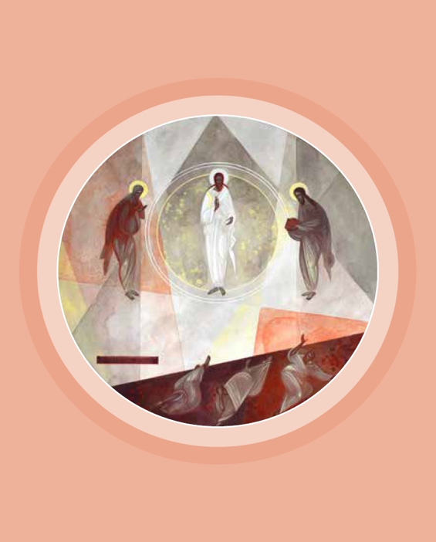
In the midst of the apostles’ astonishment, they hear the divine voice proclaim, “This is my Beloved Son . . . listen to him.” In this pivotal moment, human nature meets God, who identifies Jesus, the reflection of God’s glory, as God’s messenger and mouthpiece.
Like the apostles, we too encounter the great mystery of God’s light and love, and like Peter, we too feel the instinct to hold on to the moment. The invitation is to share the story. This mountaintop encounter is meant to be lived out in the valley of our lives where love and compassion seek a home.
Our world bears the imprint of God, and yet we experience the pain, the anguish, and, at times, the darkness swirling about us. As the transfiguration encounter helped the apostles to prepare for the crucifixion, so too it invites us to think of our own moments of everyday transfigurations, of flashes of light in the darkness.
Transfiguration, Khrystyna Kvyk

Grace is everywhere and made manifest through the mystery of the Word made flesh. God beyond our grasp chooses to come within our grasp. We are challenged, then, to open the eyes of our hearts to recognize God’s dwelling in us even in the midst of the daily struggles. Transfiguration experiences are surely lanterns of light to grip on to, which will carry us through. Sr. Edith Prendergast
Edith Prendergast, RSC, is director of religious education for the Archdiocese of Los Angeles. *This reflection was previously published in the March 2014 issue of Give Us This Day.

