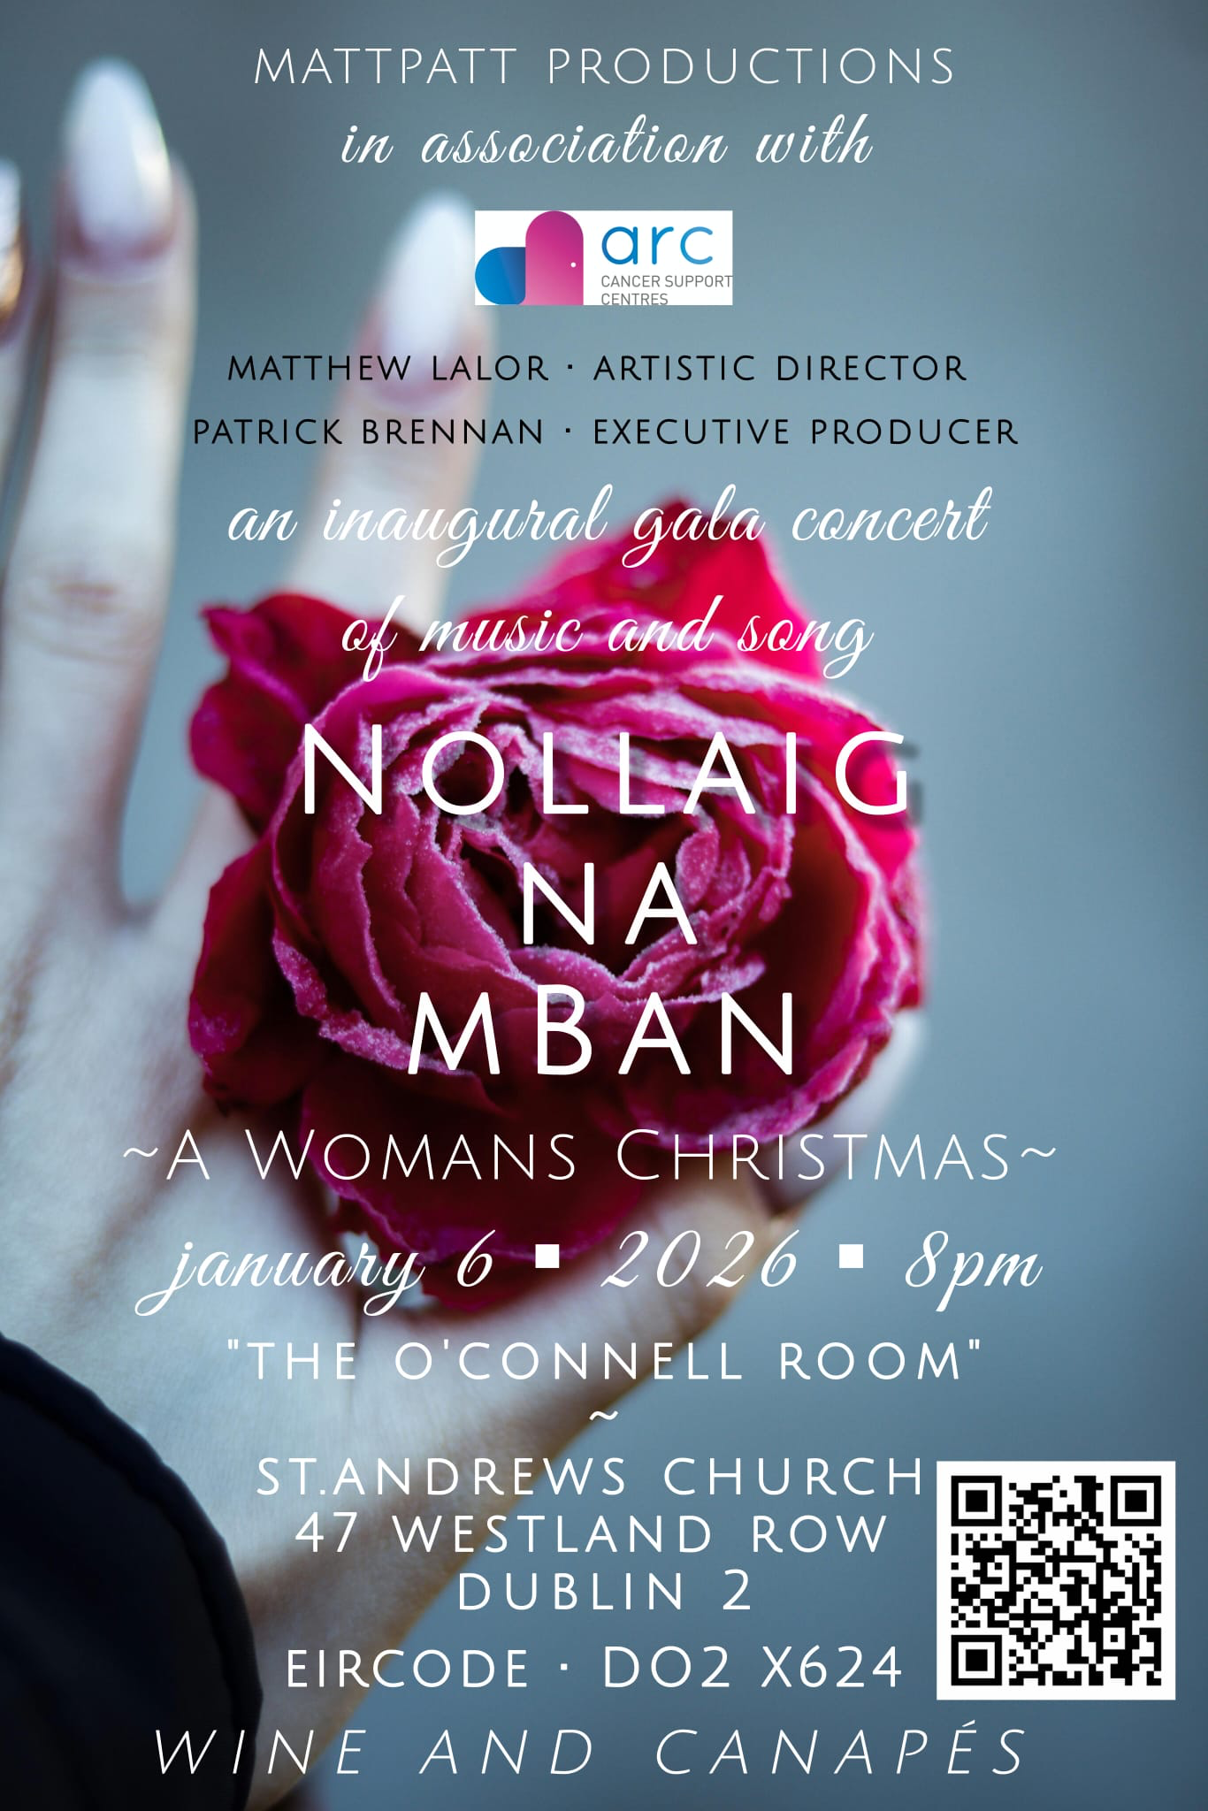
Tickets for the event advertised in the O’Connell Room in Westland Row Church are to raise money for ARC Cancer Support. Tickets start at €20.
Church Collections.
Clergy Collection 22ND/12/2025 | Share | Shrines and envelopes | Tap and Go From Fri 12th^{th} Dec. | QR Code for parish Donation…if you have no cash and wish to donate
£155 | €120 | €610 | €137  (If you require a receipt please email us) | 

A Prayer for the New Year
We stand at the threshold of a new year together.  Open the door, open the door.  Everything that was has already been,  say goodbye with gratitude.  Everything that will be is still arriving,  be not afraid.  May the new dawn delight you.  May the long nights rest you.  May the beauty of this world testify to you.  May the laughter of a friend gladden you.  May your hunger instruct you.  May the breaking of your heart ground you.  May the sorrows to come with the days also bring mercy to you.  May the hearth of this world be tended by you.  May love illuminate everything,  may love illuminate you.  May the altars of your life be ordinary.  May the sanctuary of you hold all that is to be.  May your lines fall in pleasant places.  May your longings be satisfied in wonder.  May your creativity be kindled and  may the worlds that your words create speak life.  May curiosity guide you to wisdom.  May wisdom guide you to kindness.  May kindness guide you to gentleness.  May gentleness guide you to faithfulness.  May faithfulness guide you to compassion. | And may compassion be your mother tongue,  the song you sing under your breath,  the caress of your hand,  the presence you carry into every room.  May the ancient paths guide you.  May your ancestors fortify you.  May the generosity of God astonish you.  May the prayers of the Church uphold you.  May the consolation of the Spirit satisfy you.  May the wild goose dare you.  May the love of Jesus be near to you.  Open the door, open the door.  Everything that will be is still arriving  and it comes with all that makes us human and beloved:  the harrowing, the beauty, the terrible, the glorious,  the mundane, the wondrous, the fearful, and the good.  Sweep the floors, open the windows, put the kettle on,  welcome it all as a companion.  Everything that is arriving could heal you,  and so you will be part of healing the world at your feet,  as it beckons us further into grace and goodness.  May Love be with you this year.  (Love is already with you.)  Open the door. Be not afraid.  Amen.  Sarah Bessey

.

