Church Collections.
Clergy Collection | Share | Shrines and envelopes | Tap and Go From Fri 28th Nov. | QR Code for parish Donation…if you have no cash and wish to donate
€75 | €55 | €265 | €212.50  (If you require a receipt please email us) | 

SVP COLLECTION
The diocesan collection for the Dublin Council of the Society of St Vincent de Paul will take place this weekend at all Masses as per the Diocesan Diary on the weekend of Sunday, December 7. Please be generous to this worthy cause. For those who wish to make donations directly please take an envelope on the tables at the back of the Church
Crosscare Christmas Food Poverty Appeal
As the cost of living continues to rise, more families than ever are turning to Crosscare for help. This year, almost 3,000 people – including 1,200 children – sought basic food support, while nearly 12,000 affordable meals were served in the Portland Row Community Café.
Please support our 2025 Christmas Food Poverty Appeal. Your donation – big or small – will help provide food, stability, and a pathway towards independence for those who need it most. Donate at www.crosscare.ie or call 01 8360011.
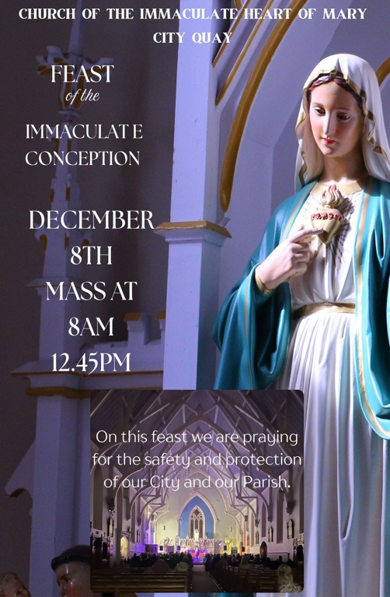 | 
Department of Education Survey - Have Your Say
The current Department of Education survey on the future of patronage in the primary sector is important in that it will shape the discussion on primary school divesting for the years to come throughout the Republic of Ireland. The survey is school specific and needs to be responded to by all parents and prospective parents locally. It is equally important that those who wish for a Catholic education for their children, and the support for sacramental preparation available in Catholic schools, would have their voice heard also. For those reasons and to ensure that an accurate picture emerges, please participate in this survey if you are a parent or a prospective parent of a Primary school student. The survey can be accessed at:
www.gov.ie/primaryschoolsurvey/. It closes on Tuesday, December 16.

