Church Collections.
Clergy Collection | Mission Sunday | Shrines and envelopes | Tap and Go From Fri 17th | QR Code for parish Donation…if you have no cash and wish to donate
€50 | €75 | €300 | € 216  (If you require a receipt please email us) | 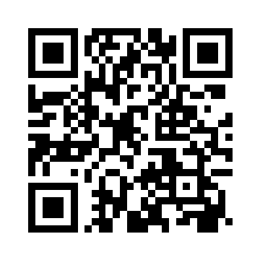

Church Refurbishment.
The Parish Pastoral Council (PPC)in consultation with the needs of members of the worshipping community have been assisting with the design brief for the refurbishment of the Church. The following items were considered by the PPC to be of importance in the upcoming works subject to budgetary constraints:
- Fit for purpose
- Secure / warm
- Prayerful space
- Accessible, giving consideration to wheelchair access etc
- Light filled [ where possible]
- Bring altar into the body of the church
- Revise entry to Church
- Re-imagine / relocate shrines
- Possible room at the back - where Priest could robe for Mass or could be used as a small prayer space.
- No leaks.
- Reducing number of benches to ease access and reduce risk.
- Re- locate baptismal font.

Sacrament of First Penance, Communion and Confirmation.  Thanks to those who have registered for the above Sacraments  Those who have yet to register are asked to register on the following form. Please be aware a Baptismal Certificate is required to fully register as is participation in the program of preparation.  https://forms.office.com/e/UBwKBZeJeq | 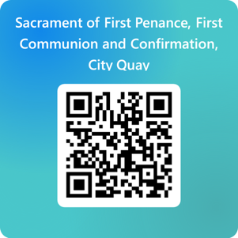

All Saints
The Feast of All Saints falls on Saturday the 1st of November. Mass for the feast will be celebrated in Saint Andrew’s Westland Row at 10 am. The only mass in City Quay will be at 6 pm which a person can attend to fulfil their Holy Day or Sunday obligation.

All Souls
On Saturday evening the 1st of November we will remember all those who died during the year and were buried from this Church. Family members will be in attendance. There will be an opportunity to remember our own relatives and friends who we commend to the mercy of God this Jubilee Year,

Young Adult Program
Over the next number of months we hope to be introducing a Young Adult Faith Formation Program. It will take place on Thursday evenings. Location and dates will be published in advance. We will register expressions of interest over the next few weeks. The program is entitled ‘Wrestling with God’ and is based on a program taught by Fr Alan in the University of Notre Dame USA. If you are interested or would like to chat about the program please feel free to contact Fr. Alan.

