Church Collections.
Clergy Collection | Share | Shrines and envelopes | Tap and Go From Fri 12th | QR Code for parish Donation…if you have no cash and wish to donate
€65 | €55 | €340 | €136  (If you require a receipt please email us) | 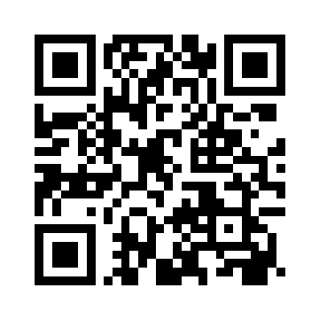

Church Refurbishment.
On Saturday the 18th of October the gas connector was put in place for the heating system for the Church Refurbishment. This is the first building work relating to the refurbishment.

Sacrament of First Penance, Communion and Confirmation.  Thanks to those who have registered for the above Sacraments  Those who have yet to register are asked to register on the following form. Please be aware a Baptismal Certificate is required to fully register as is participation in the program of preparation.  https://forms.office.com/e/UBwKBZeJeq | 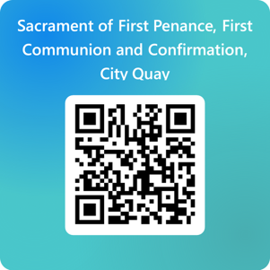
The Second Collection this weekend is to support the work of the Missions  The theme for this year’s celebration of Mission Sunday is: “Missionaries of Hope Among All Peoples”. | 
Remembering
The Annual Mass to remember those who died during this last calendar year will take place on Saturday the 1st of November at the regular 6 pm Mass. For details contact Bernie at the parish office.

MANRESA RETREATS
Manresa Jesuit Centre of Spirituality (Clontarf, Dublin) is offering the following:
Advent Triduum Retreat. Monday-Friday, 1-5 December or 8-12 December 2025. A silent retreat guided by the Jesuit community, offering space for prayer, reflection, daily Mass, adoration, and the Sacrament of Reconciliation, in preparation for Christmas.
New Year Retreat. Monday, 29 December 2025 - Thursday, 1 January 2026. Welcome the New Year in a spirit of peace and prayer. This silent retreat offers time to reflect on the year gone by, seek God’s grace for the year ahead, and be guided by daily prayer and liturgy.
Oasis Day. Saturday, 15 November, 6 December, or 13 December 2025. Take a sacred pause before the year ends. Choose any one of these single-day retreats to rest, pray, and be refreshed in spirit. “Come away and rest for a while.” (Mark 6:31)
Bookings can be made online (manresa.ie), by email at reception@manresa.ie, or by calling +353 1 5529 448. Visit www.manresa.ie for more details.

